ELITE ZONE J

Photoshoot Brief
Reference and delivery specification for editorial and product imagery

2026-05-08

This document is the complete shotlist and delivery specification for the Elite Zone J site re-shoot. It covers fifteen distinct image roles across the home page, product cards, product detail pages, fabric pages, and editorial sections.
Each section below lists where the image appears on site, the exact pixel and aspect-ratio requirements, the file naming and folder structure to deliver against, and direction for composition and mood. A reference image from the current site is embedded with each section so you can match framing and tone, not just specification.

Global delivery requirements
These rules apply to every image in this brief unless explicitly overridden in a section.
Final format | .webp at quality 82–88, sRGB IEC61966-2.1
Master archive | Also deliver a 16-bit .png or .tiff master for every shot
Resolution | Deliver at 2× the listed minimum dimensions (Retina / 4K coverage)
Colour profile | sRGB. Include grey card and ColourChecker frame in every setup
Watermarks | None. No embedded copyright text. No borders or vignettes
Background | Clean studio neutral (linen / off-white / charcoal seamless) unless section calls for editorial environment
Lighting | Soft, directional. No harsh fill. Daylight 5500K preferred for fabric and detail; warm tungsten acceptable for atelier / editorial
Retouching | Light skin retouch acceptable. NO liquify on garments. Fabric texture must be preserved
Naming | lowercase-kebab-case, .webp extension. Match the file paths in this brief exactly
Folder structure | Mirror /public/generated/ tree shown per section
Handoff | Single .zip archive: assets/ + masters/ + contact-sheet.pdf + shotlist.csv

Section 1 — Hero Grid Tiles
Home page, top of viewport. Three editorial tiles in a row on desktop; auto-advancing carousel on mobile.

File paths
- public/generated/_hero/premium.webp
- public/generated/_hero/new-arrivals.webp
- public/generated/_hero/made-to-measure.webp

Specification
Aspect ratio | 3 : 4 (desktop) / 4 : 5 (mobile, cropped from same shot)
Minimum dimensions | 1100 × 1466 px
Delivered (2×) | 2200 × 2932 px
File format | .webp (also deliver master as 16-bit .png or .tiff)
Quality | Quality 82–88, sRGB
Naming | premium.webp, new-arrivals.webp, made-to-measure.webp
Folder | /public/generated/_hero/
Quantity | 3 hero tiles (1 per scene)

Direction
- Subject framed centre-vertical so a 4:5 mobile crop preserves the focal point.
- Editorial mood — subject in motion or in calm presence, never catalogue-flat.
- Light: directional natural light or soft window light. No harsh fill.
- Premium: master tailoring, three-piece, refined.
- New arrivals: fresh seasonal pieces, lighter palette.
- Made-to-measure: atelier setting, fitting in progress, hand on cloth.

Reference — match this composition / mood

premium.webp

new-arrivals.webp
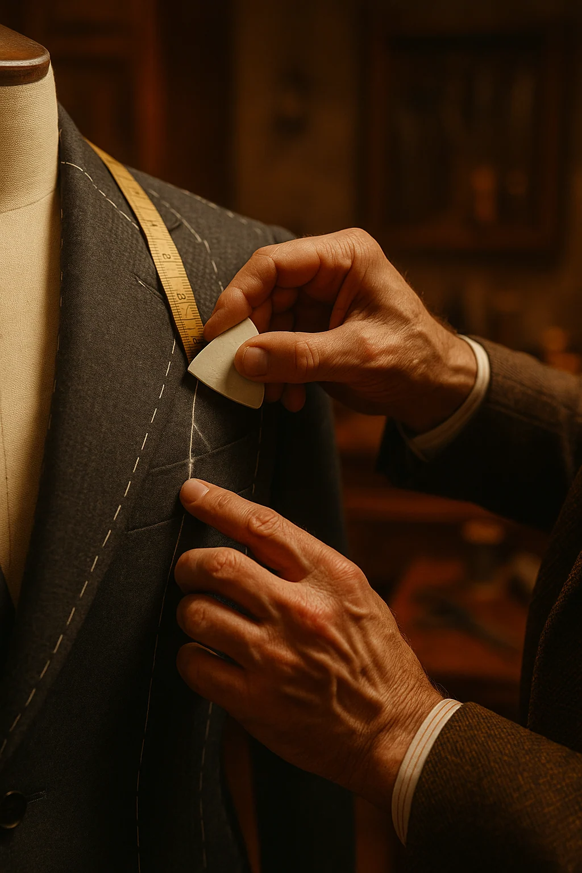
made-to-measure.webp

Section 2 — Product Card Gallery — Tailored Garments
Home carousels (New In, Festive Edit), Editorial Splits, Collection grids, PDP 'Complete the look'. Mobile auto-cycles 3 of 5 angles every 3.5s.

File paths
- public/generated/{slug}/01-front.webp
- public/generated/{slug}/02-overview.webp
- public/generated/{slug}/03-side.webp
- public/generated/{slug}/04-back.webp
- public/generated/{slug}/05-detail.webp

Specification
Aspect ratio | 3 : 4 (grids) / 7 : 10 (carousels & editorial splits) — shoot tighter 3:4 with safe zone
Minimum dimensions | 1200 × 1600 px
Delivered (2×) | 2400 × 3200 px
File format | .webp (master .tiff)
Quality | Quality 85, sRGB
Naming | 01-front.webp, 02-overview.webp, 03-side.webp, 04-back.webp, 05-detail.webp
Folder | /public/generated/{slug}/ — one folder per SKU
Quantity | 20 SKUs × 5 angles = 100 shots

Direction
- Background: clean studio neutral (linen / off-white / soft charcoal seamless).
- Model: same model preferred per gender for visual consistency.
- Hands always considered — no thumbs-in-pockets unless deliberate.
- Garment must read fully — no cropping at hem, sleeve cuff, or shoulder seam.
- Detail shot is critical: macro of weave, lapel, working button, hand-finish, or hardware.

Reference — match this composition / mood
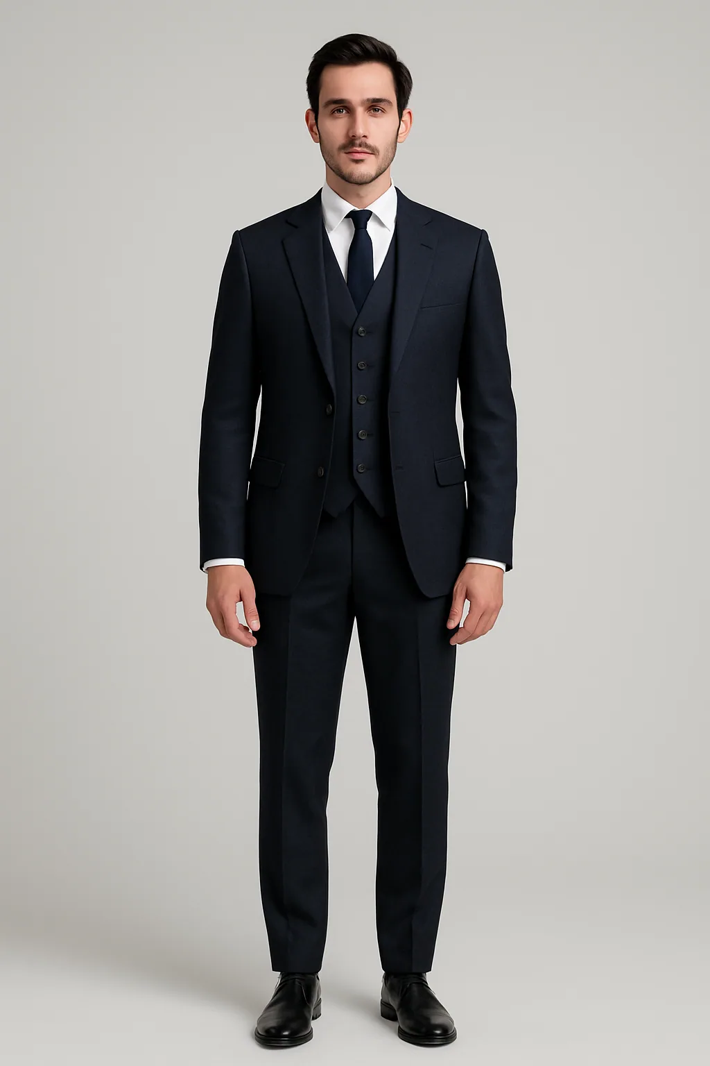
01-front.webp
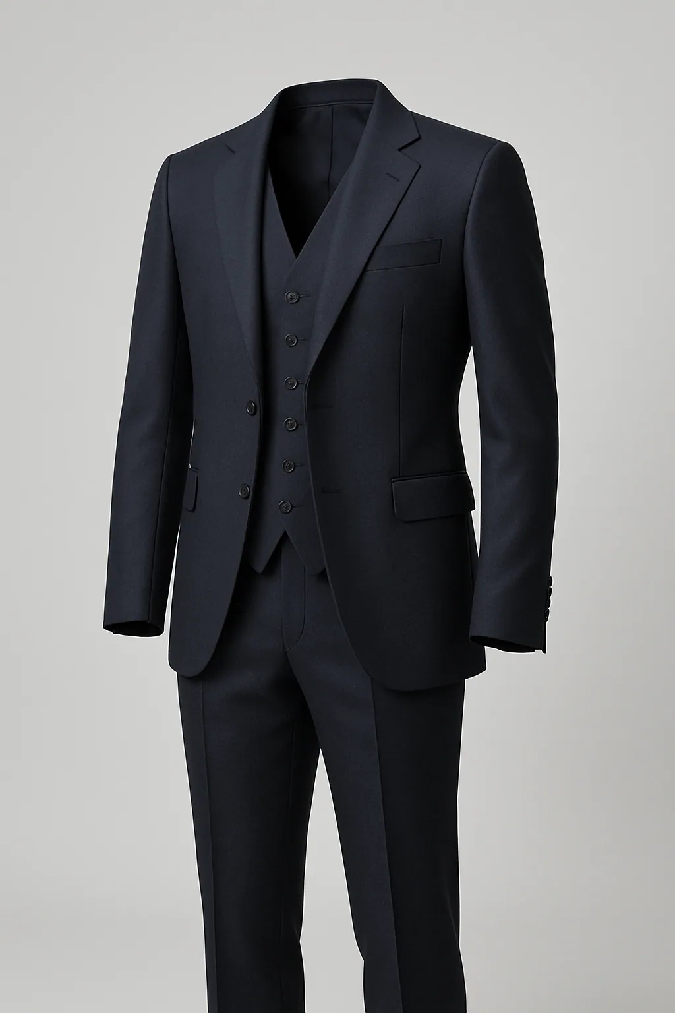
02-overview.webp
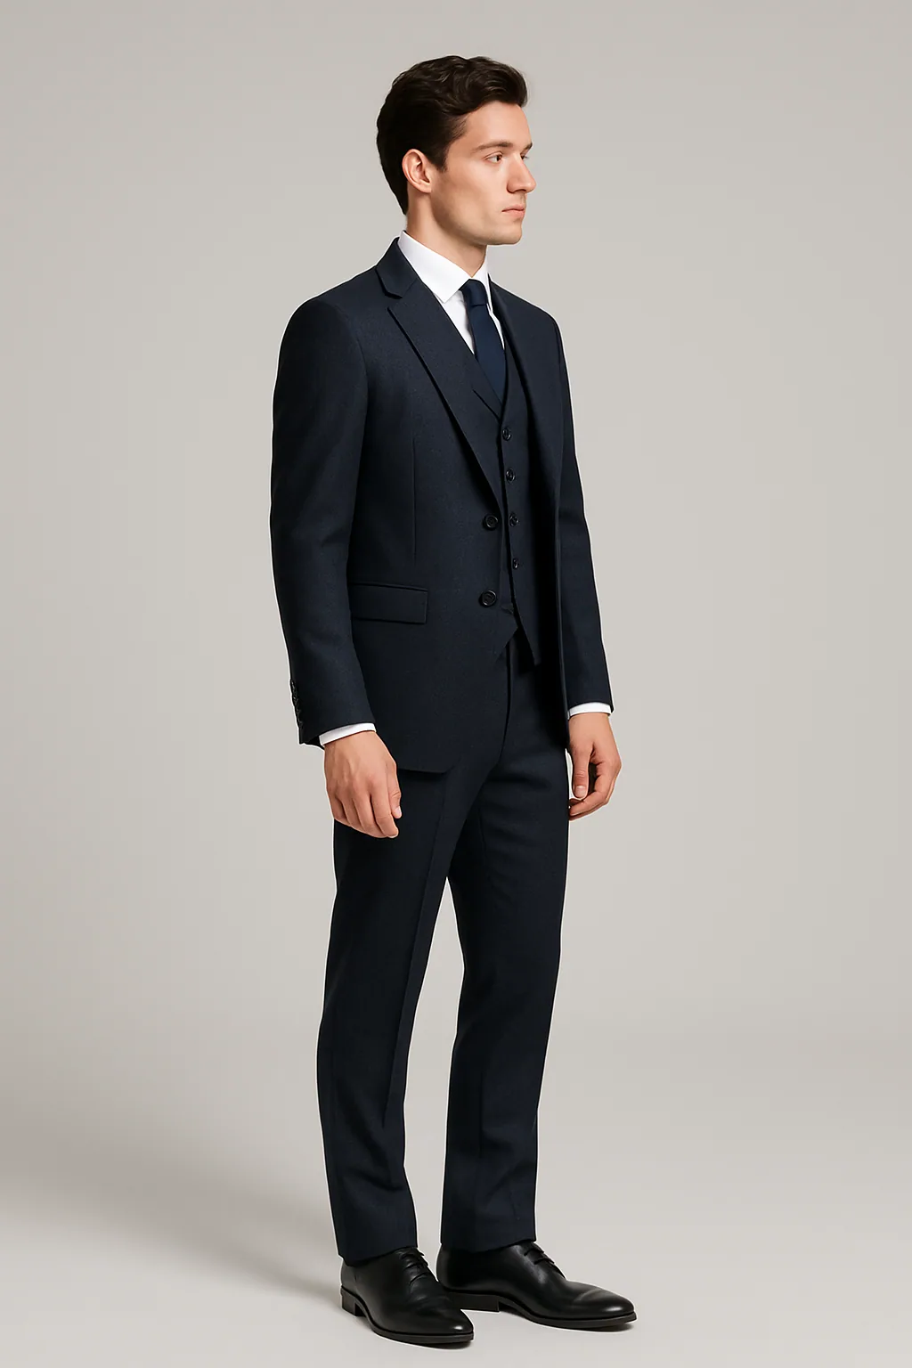
03-side.webp
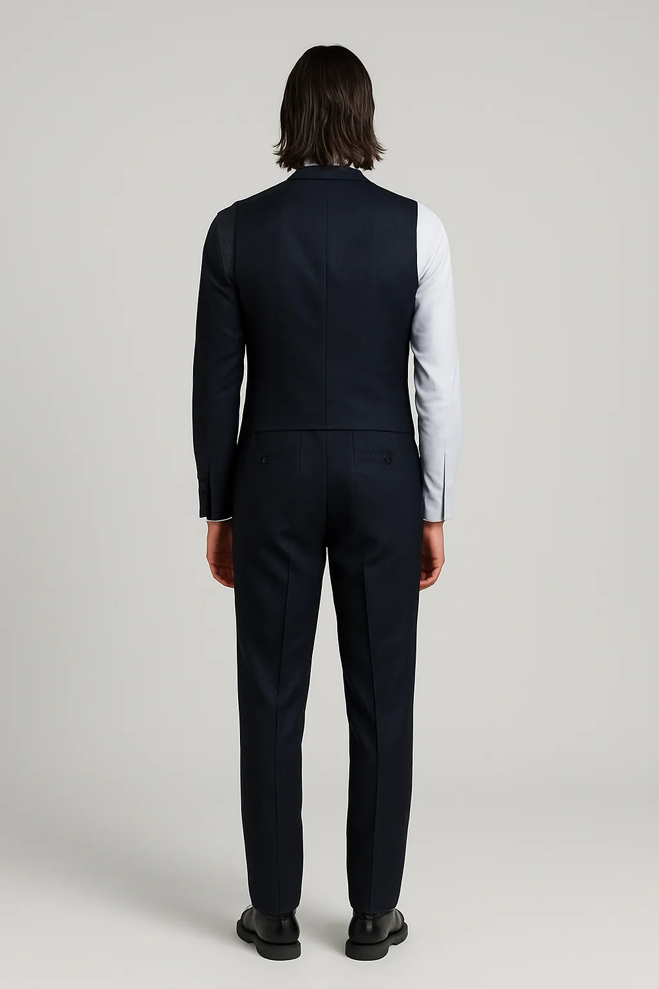
04-back.webp
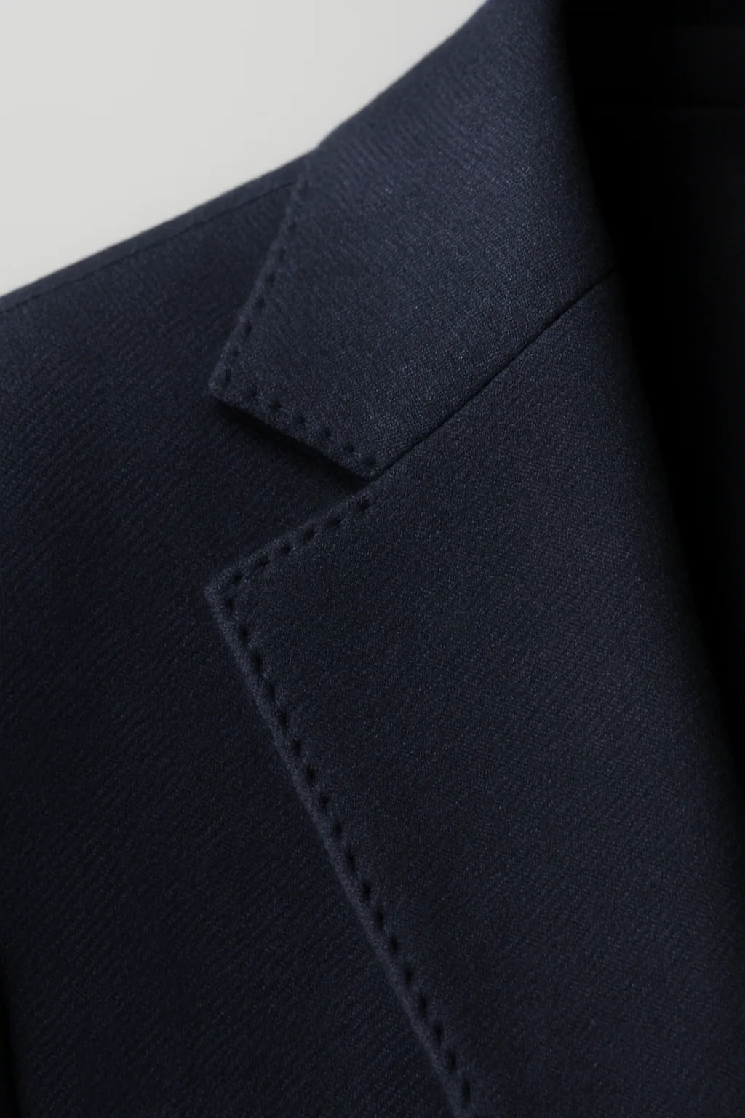
05-detail.webp

Section 2a — Tailored SKU index
Every slug below requires the full 5-angle set described in Section 2. Twenty garments × five angles = one hundred shots.
Slug | Category | Angles required
acetate-glasses | Accessory | 01·02·03·04·05
aria-pant-suit | Womenswear | 01·02·03·04·05
black-tie-tuxedo | Menswear / Formal | 01·02·03·04·05
calfskin-belt | Accessory | 01·02·03·04·05
camel-trench | Outerwear | 01·02·03·04·05
embroidered-lehenga | Womenswear / Festive | 01·02·03·04·05
festive-sherwani | Menswear / Festive | 01·02·03·04·05
grandad-collar-shirt | Menswear / Shirts | 01·02·03·04·05
hand-laced-corset | Womenswear | 01·02·03·04·05
heritage-three-piece | Menswear / Tailoring | 01·02·03·04·05
italian-pleated-trouser | Menswear / Trousers | 01·02·03·04·05
lapel-brooch-set | Accessory | 01·02·03·04·05
linen-bandhgala | Menswear / Festive | 01·02·03·04·05
midnight-slip-dress | Womenswear | 01·02·03·04·05
raw-silk-saree | Womenswear / Festive | 01·02·03·04·05
tailored-pencil-skirt | Womenswear | 01·02·03·04·05
tapered-wool-trouser | Menswear / Trousers | 01·02·03·04·05
two-piece-italian | Menswear / Tailoring | 01·02·03·04·05
velvet-blazer-dress | Womenswear | 01·02·03·04·05
wide-calfskin-belt | Accessory | 01·02·03·04·05

Section 3 — Product Detail Page (PDP) Gallery
Individual product pages. Same 5 angles as Section 2, but rendered far larger with a hover zoom magnifier and full-screen lightbox.

File paths
- public/generated/{slug}/{angle}.webp (same files as Section 2 — must be high enough resolution for both)

Specification
Aspect ratio | 2 : 3 main gallery / 2 : 3 thumbnails
Minimum dimensions | 1440 × 2160 px (required for hover zoom magnifier sharpness)
Delivered (2×) | 2880 × 4320 px
File format | .webp (master .tiff)
Quality | Quality 88, sRGB — slightly higher than card variant
Naming | Same as Section 2
Folder | /public/generated/{slug}/
Quantity | Same files as Section 2 — shoot once, deliver at PDP resolution

Direction
- Detail shots MUST be macro-sharp — they are zoomed on hover up to 2× on desktop.
- No motion blur, no camera shake, even on full-body angles.
- Tripod recommended for all angles. Lens: 85mm or 100mm macro for detail.

Reference — match this composition / mood
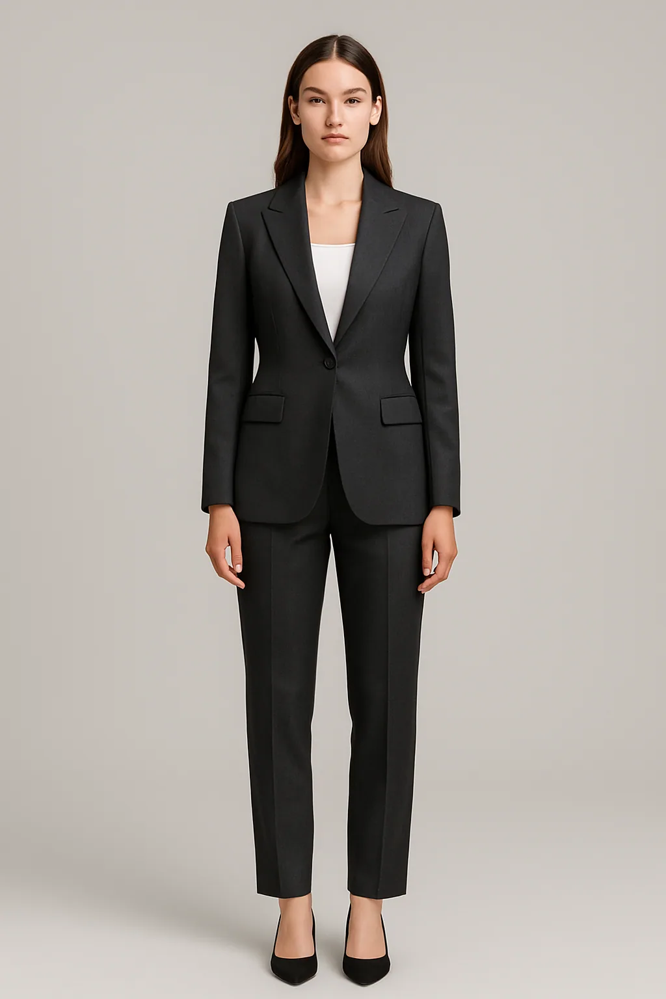
01-front.webp
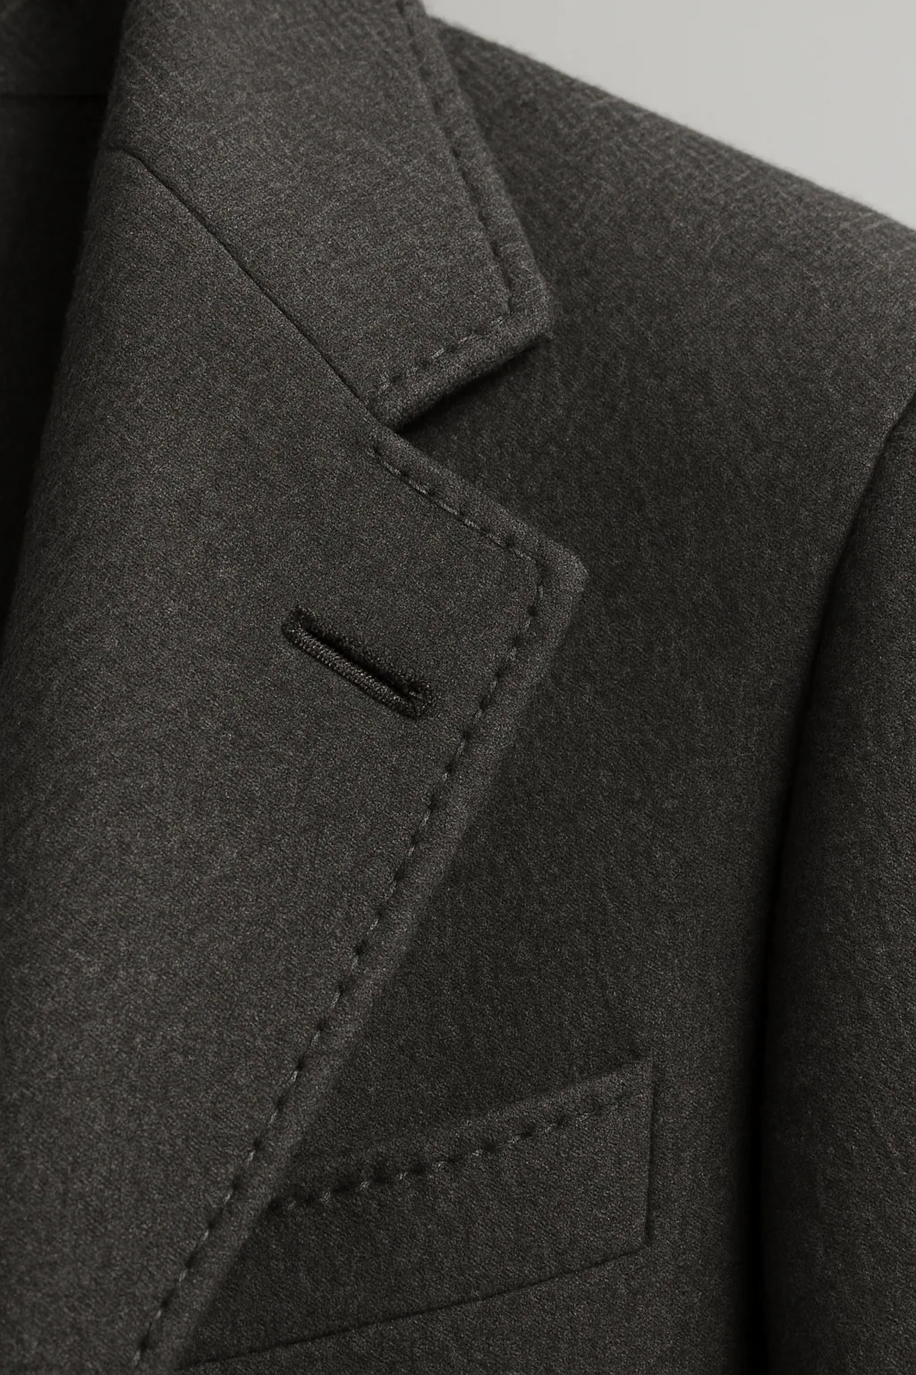
05-detail.webp

Section 4 — Fabric PDP Gallery
Fabric product detail pages. Swatch-focused, no garment.

File paths
- public/generated/{fabric-slug}/{colour-slug}/front.webp
- public/generated/{fabric-slug}/{colour-slug}/drape.webp
- public/generated/{fabric-slug}/{colour-slug}/lay.webp
- public/generated/{fabric-slug}/{colour-slug}/detail.webp

Specification
Aspect ratio | 2 : 3
Minimum dimensions | 1440 × 2160 px
Delivered (2×) | 2880 × 4320 px
File format | .webp (master .tiff)
Quality | Quality 88, sRGB
Naming | front.webp, drape.webp, lay.webp, detail.webp
Folder | /public/generated/{fabric-slug}/{colour-slug}/
Quantity | 4 fabrics — primary colour: 4 angles each. Secondary colours: front.webp only.

Direction
- Drape: cloth draped over a tailor's block or dummy — shows hand, weight, fall.
- Lay: flat with selvedge along one edge; raking light to catch weave.
- Detail: 1:1 macro showing yarn structure, weave geometry, slubs (silk), wales (wool).
- Front: bolt photographed flat with label corner visible.
- Colour fidelity is critical — shoot under D65 / 5500K, include grey card in setup frame.

Reference — match this composition / mood
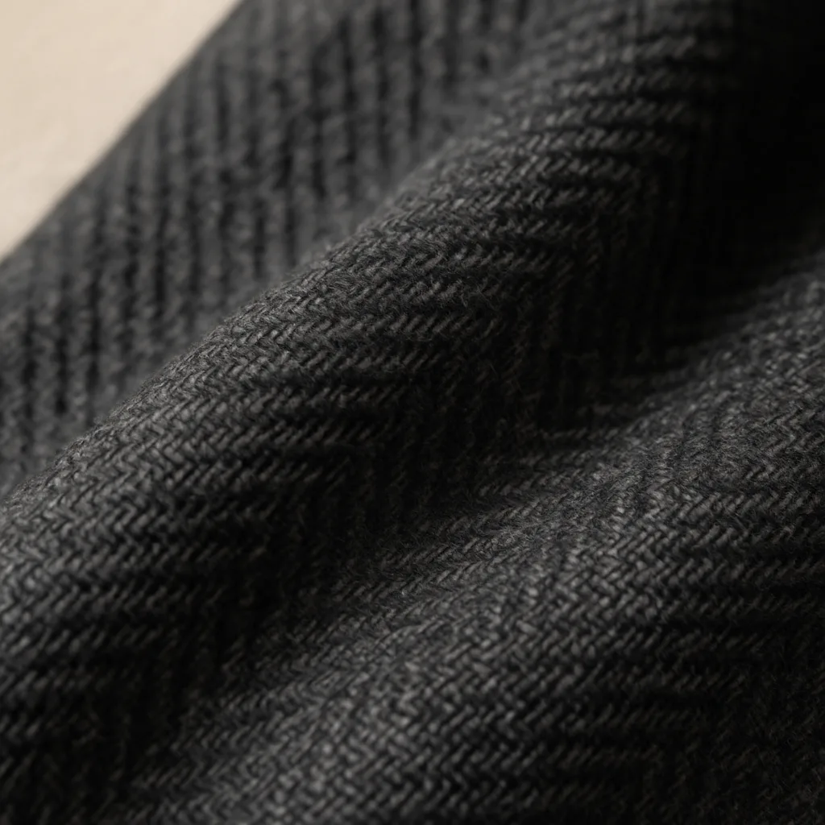
front.webp
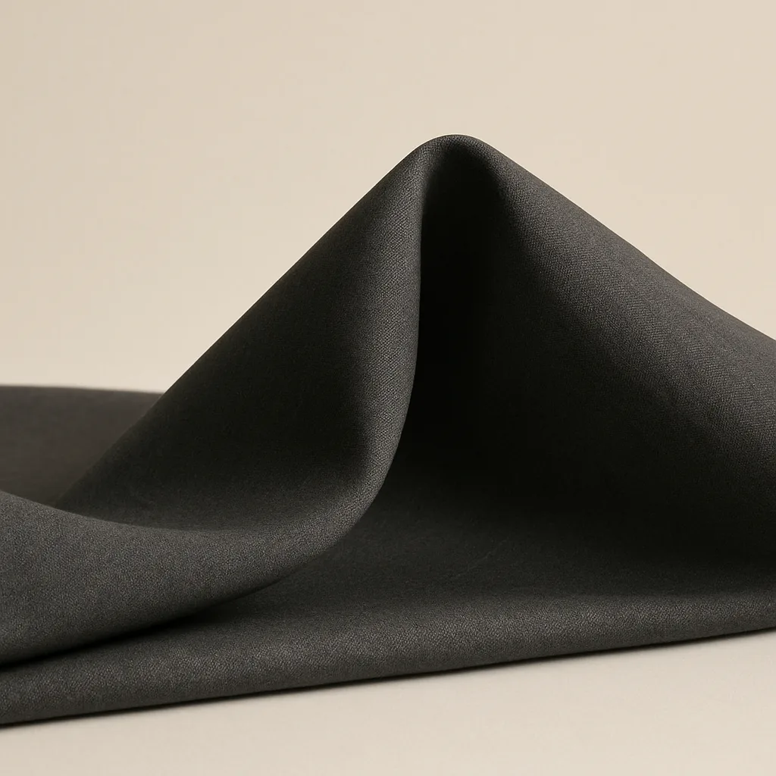
drape.webp
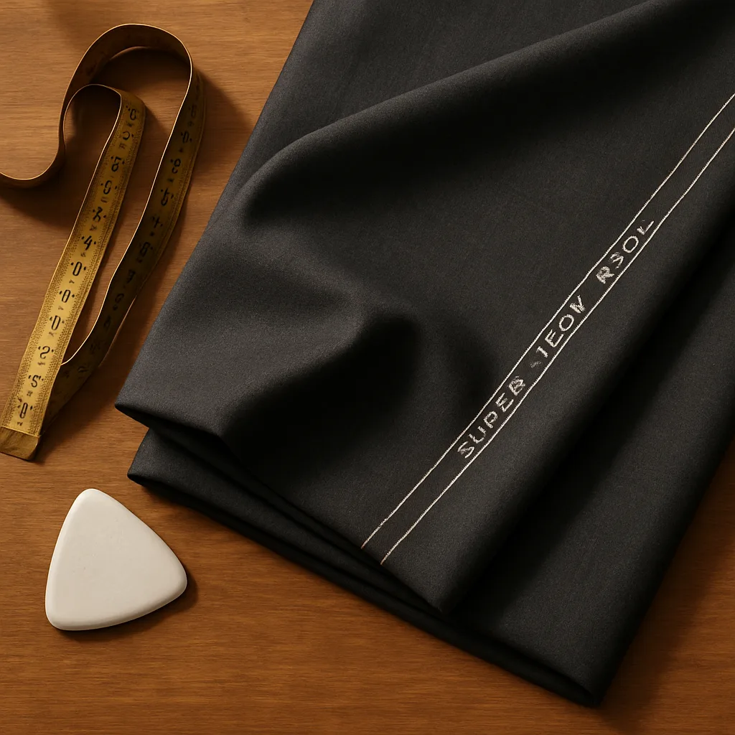
lay.webp
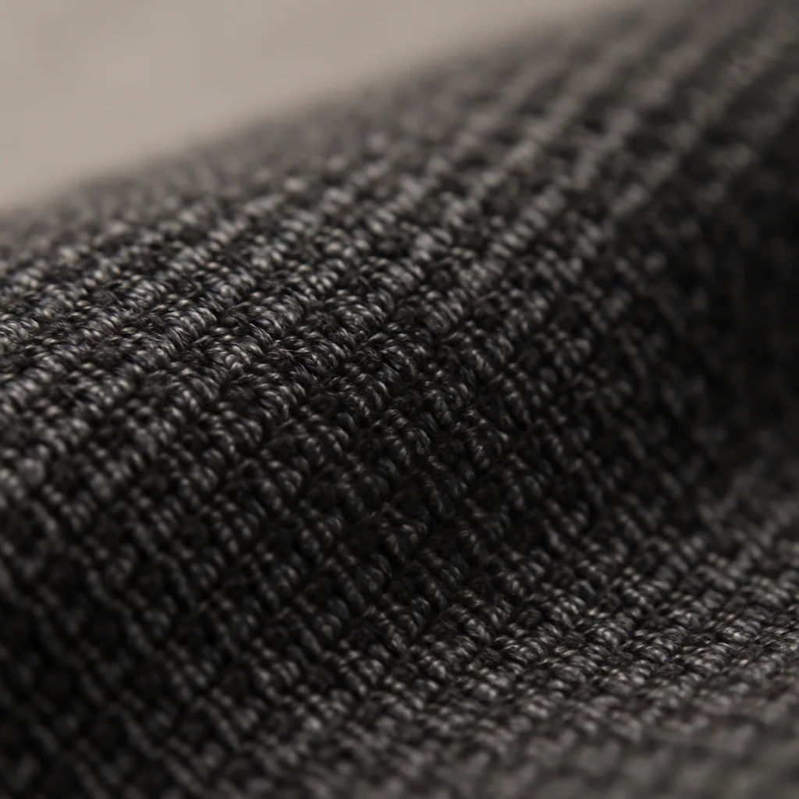
detail.webp

Section 4a — Fabric colourway matrix
Each fabric has one primary colourway shot at all four angles, plus secondary colourways shot front-only (the site falls back to the primary colour for the other angles when the user picks a secondary swatch).
Fabric | Colourway | Angles | Notes
Egyptian Poplin | ivory | front · drape · lay · detail | PRIMARY — full set
Heavy Linen | sand | front · drape · lay · detail | PRIMARY — full set
 | slate | front | secondary — front only
Italian Wool Super 120s | charcoal | front · drape · lay · detail | PRIMARY — full set
 | bone | front | secondary — front only
 | navy | front | secondary — front only
 | stone | front | secondary — front only
Raw Silk Handwoven | wine | front · drape · lay · detail | PRIMARY — full set
 | emerald | front | secondary — front only
 | ivory | front | secondary — front only

Section 5 — Editorial Split Image
Home page — large image paired with a 6-card product grid. Two appearances: 'The Men's Edit' (image left) and 'The Women's Edit' (image right).

File paths
- public/generated/_sections/atelier.webp
- (women's edit reuses a product hero — designate a dedicated editorial)

Specification
Aspect ratio | Tall — square-tolerant. Site uses CSS background-size: cover.
Minimum dimensions | 1400 × 1400 px (square safe-zone) — shoot 1600 × 2000 px or wider
Delivered (2×) | 2800 × 2800 px
File format | .webp (master .tiff)
Quality | Quality 85, sRGB
Naming | atelier.webp, womens-edit.webp
Folder | /public/generated/_sections/
Quantity | 2 editorial splits

Direction
- Atelier (men's edit): craftsmanship-leaning — hands on cloth, scissors, master tailor at work.
- Women's edit: editorial portrait — confident, refined, soft natural light.
- Shoot wide with a generous safe zone — site crops aggressively at narrow viewports.
- Mood is meditative and quiet, not commercial.

Reference — match this composition / mood
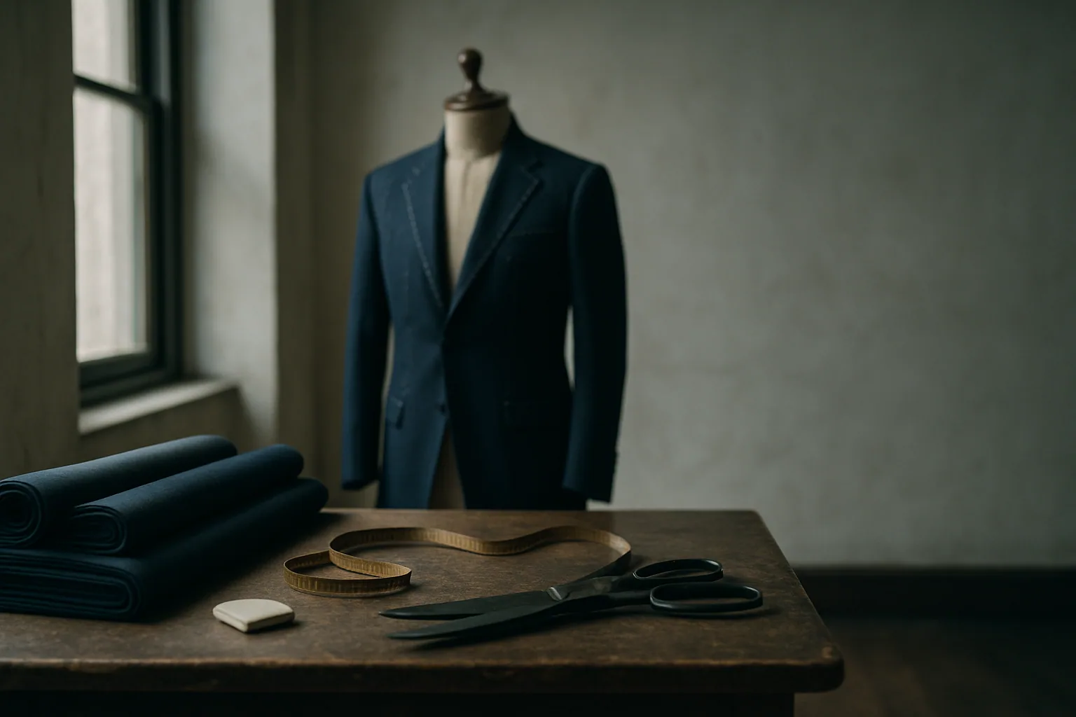
atelier.webp
01-front.webp

Section 6 — Made For You — Service Cards
Home page 'Made for you' section. Three cards on desktop, swipeable carousel on mobile.

File paths
- public/generated/_sections/service-bespoke.webp
- public/generated/_sections/service-sherwani.webp
- public/generated/_sections/service-shirts.webp

Specification
Aspect ratio | 4 : 3
Minimum dimensions | 1200 × 900 px
Delivered (2×) | 2400 × 1800 px
File format | .webp (master .tiff)
Quality | Quality 85, sRGB
Naming | service-bespoke.webp, service-sherwani.webp, service-shirts.webp
Folder | /public/generated/_sections/
Quantity | 3 service cards

Direction
- Each card depicts the *making* of one service — not the finished result.
- Bespoke: client fitting, master tailor with measuring tape, mirror behind.
- Sherwani: zardozi or hand-embroidery in progress, craftsman's hands.
- Shirts: shirt construction — collar set, button-stand, mother-of-pearl buttons close.
- Light is warm, intimate, document-style.

Reference — match this composition / mood
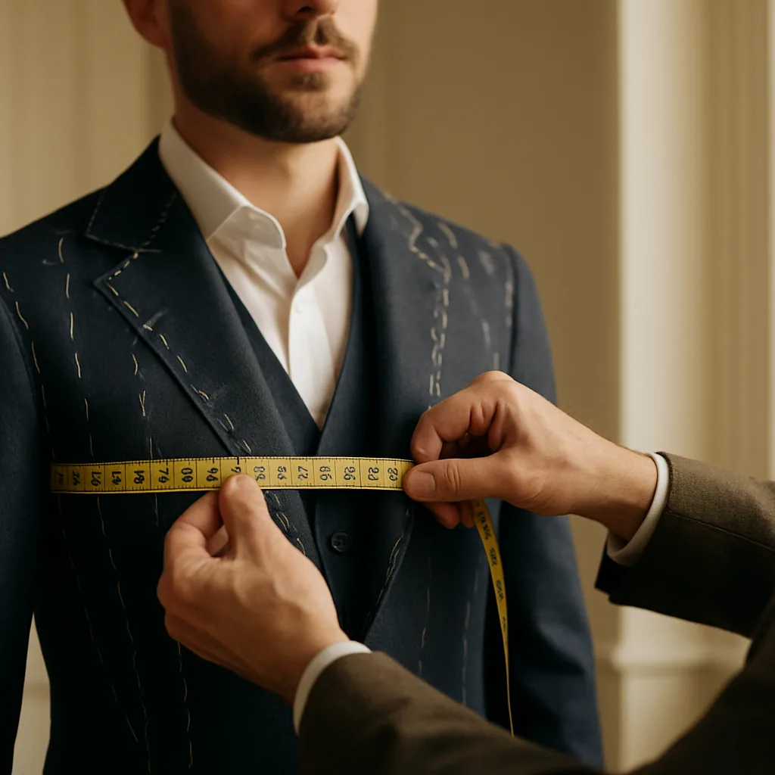
service-bespoke.webp
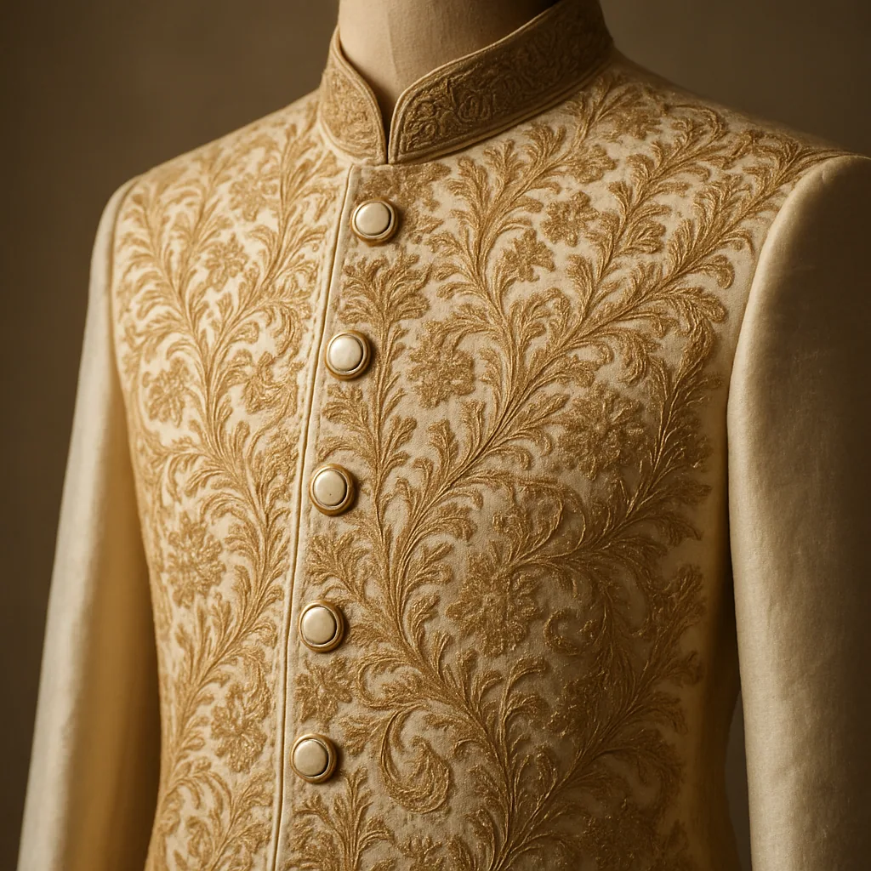
service-sherwani.webp
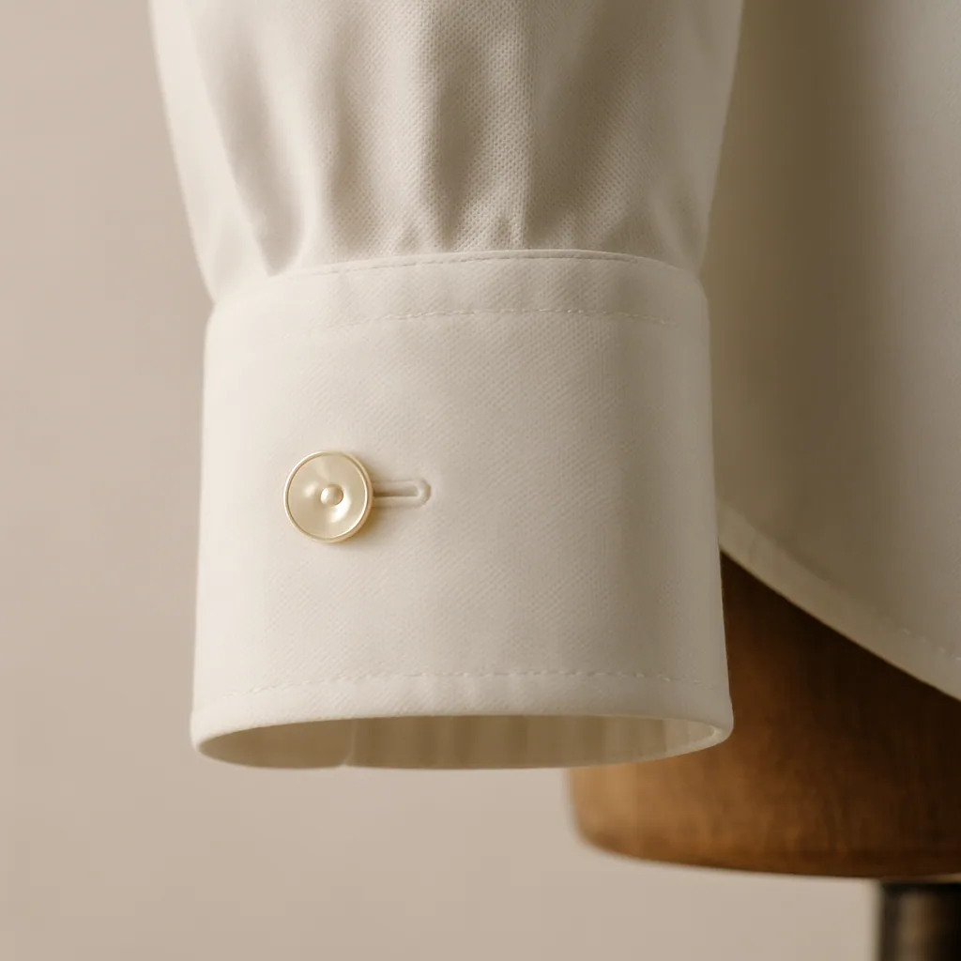
service-shirts.webp

Section 7 — Process Strip — How It's Made
Home page 'How it's made' three-step strip. Documentary-style storytelling.

File paths
- public/generated/_sections/process-cloth.webp
- public/generated/_sections/process-measure.webp
- public/generated/_sections/process-finish.webp

Specification
Aspect ratio | 4 : 3
Minimum dimensions | 1200 × 900 px
Delivered (2×) | 2400 × 1800 px
File format | .webp (master .tiff)
Quality | Quality 85, sRGB
Naming | process-cloth.webp, process-measure.webp, process-finish.webp
Folder | /public/generated/_sections/
Quantity | 3 process steps

Direction
- Step 1 — Cloth: cloth library / bolts shelved, hand selecting a roll.
- Step 2 — Measure: master tailor measuring; tape across shoulder, chalk on cloth.
- Step 3 — Finish: finished suit pressed and hanging on a wooden hanger; iron + steam visible.
- Documentary, hand-led, no model eye-contact.
- Light: warm tungsten or window-fall.

Reference — match this composition / mood
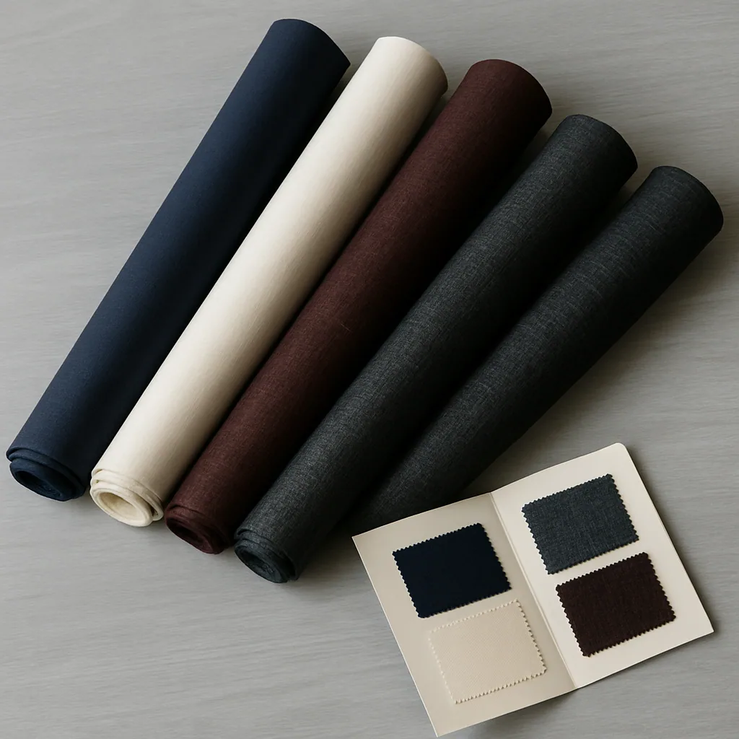
process-cloth.webp
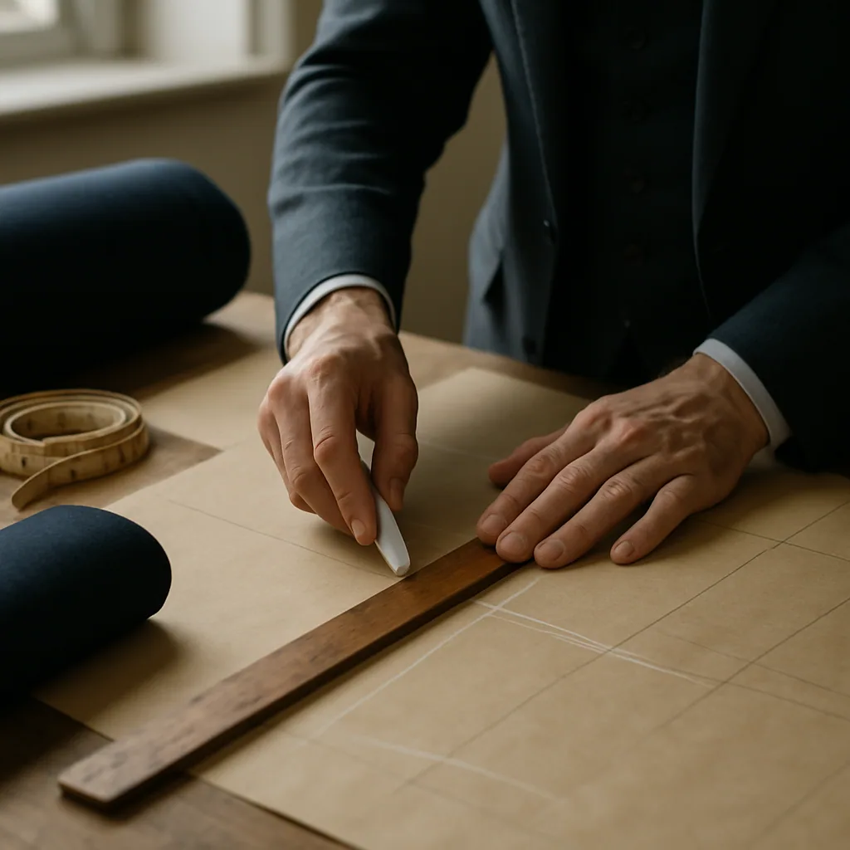
process-measure.webp
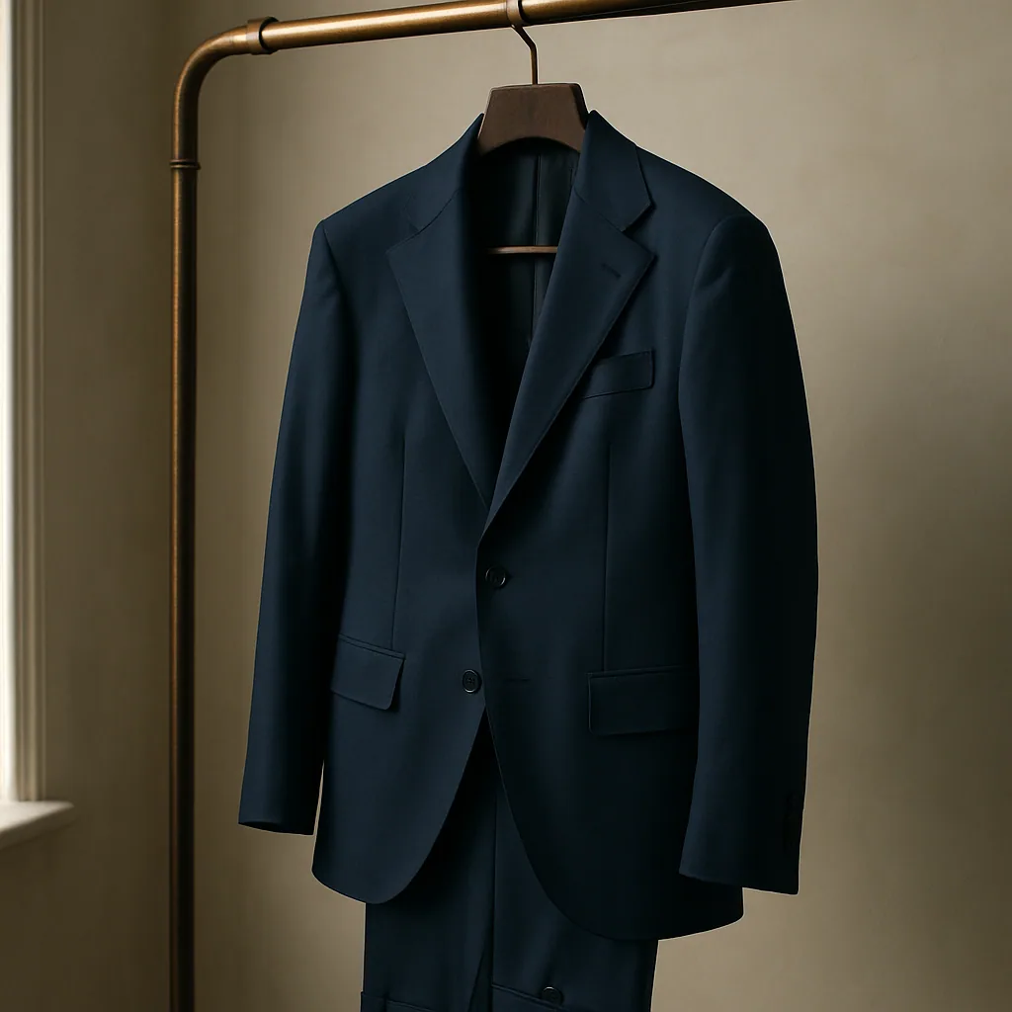
process-finish.webp

Section 8 — Editorial Section Image — Wedding Wardrobe
Home page 'The Wedding Wardrobe' editorial — image left, copy right.

File paths
- public/generated/_sections/editorial-wedding.webp

Specification
Aspect ratio | Portrait-leaning, ~4 : 5 to 5 : 6
Minimum dimensions | 1400 × 1200 px
Delivered (2×) | 2800 × 2400 px
File format | .webp (master .tiff)
Quality | Quality 85, sRGB
Naming | editorial-wedding.webp
Folder | /public/generated/_sections/
Quantity | 1 image

Direction
- Wedding-wardrobe editorial: ambient warmth, candid moment.
- Subject(s) in festive Indian wear (sherwani, lehenga). Indoor or golden-hour outdoor.
- Composition leaves negative space top-right for overlay headline.

Reference — match this composition / mood
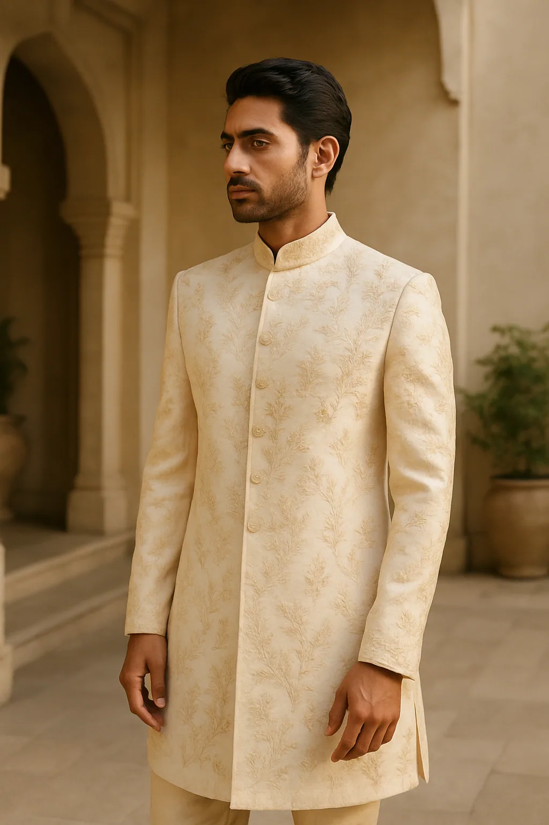
editorial-wedding.webp

Section 9 — Full-Width Collection Banner
Home page — full-bleed landscape banner linking into a collection.

File paths
- public/generated/_sections/swim-banner.webp

Specification
Aspect ratio | ~3 : 1 to 4 : 1 (cinematic landscape)
Minimum dimensions | 2400 × 800 px
Delivered (2×) | 4800 × 1600 px
File format | .webp (master .tiff)
Quality | Quality 82, sRGB
Naming | {collection}-banner.webp (e.g. womens-banner.webp)
Folder | /public/generated/_sections/
Quantity | 1 banner per collection callout (replace swim-banner with the appropriate collection)

Direction
- Cinematic landscape; subject left or right with strong negative space for overlay text + CTA button.
- Wide focal length but no fish-eye distortion.
- Strong horizon line — water, road, architecture, etc.

Reference — match this composition / mood
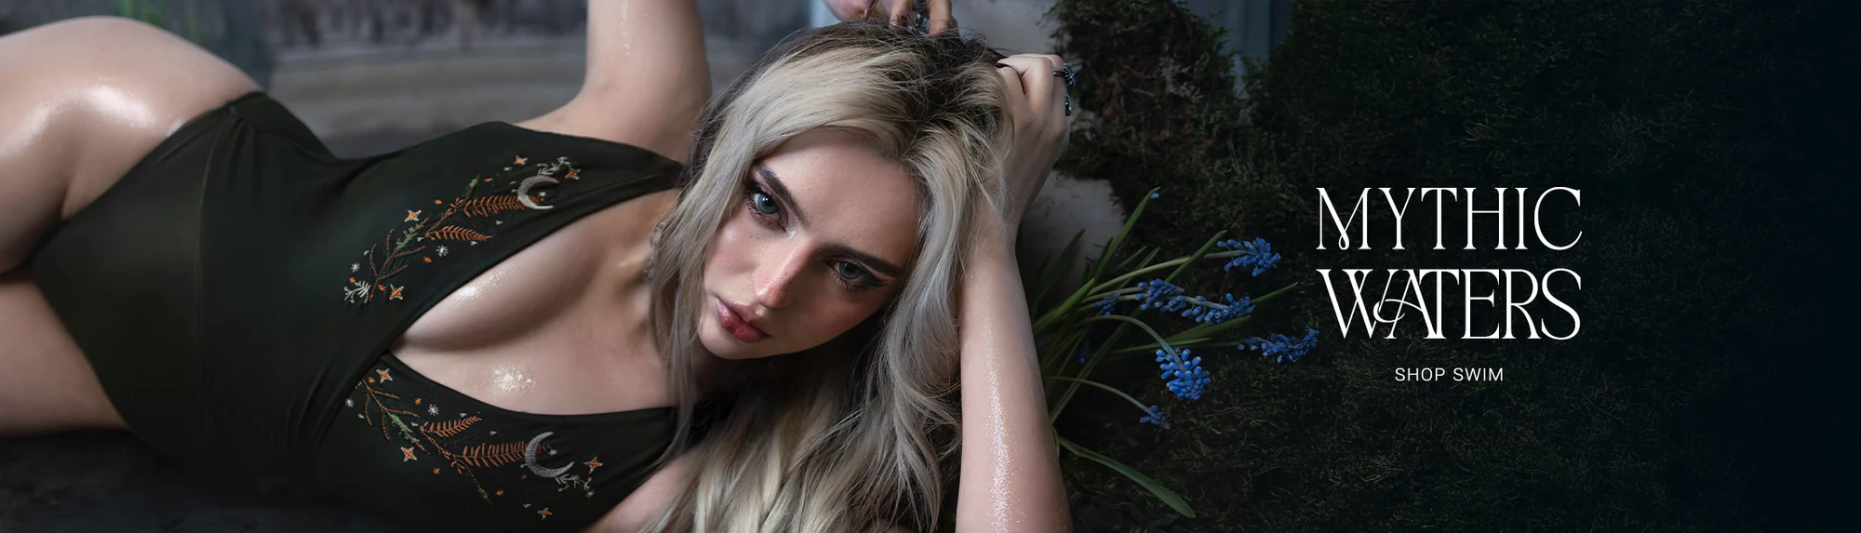
swim-banner.webp

Section 10 — Bespoke Teaser Background (Atelier reuse)
Home page 'Visit the atelier' dark band. Reuses atelier.webp under a 92→35% dark gradient overlay.

File paths
- public/generated/_sections/atelier.webp (same file as Section 5)

Specification
Aspect ratio | Inherits from Section 5
Minimum dimensions | Same as Section 5 (1400 × 1400 px square-safe)
File format | .webp
Quality | Site applies a heavy dark gradient — slight underexposure tolerated.
Naming | atelier.webp
Folder | /public/generated/_sections/
Quantity | 0 new shots required — reuses Section 5 deliverable

Direction
- No separate shoot needed. Listed for completeness — covered by Section 5.
- If shooting fresh, ensure left third of frame has dark / busy detail (the band overlays a left-to-right gradient that lightens to the right).

Reference — match this composition / mood
atelier.webp

Section 11 — Designer Portrait Slot
Currently inactive on site — placeholder slot on PDP 'Designer's note' section. Ready to wire in.

File paths
- public/generated/_team/team-aman.webp
- public/generated/_team/team-riya.webp
- public/generated/_team/team-vikram.webp

Specification
Aspect ratio | 1 : 1 or 3 : 4 portrait
Minimum dimensions | 800 × 800 px (square) or 800 × 1066 px (3:4)
Delivered (2×) | 1600 × 1600 px
File format | .webp (master .tiff)
Quality | Quality 88, sRGB
Naming | team-{firstname}.webp
Folder | /public/generated/_team/
Quantity | 3 portraits (or one per designer on the team)

Direction
- Editorial portrait against linen-tone backdrop (off-white / champagne).
- Soft natural light, predominantly window-fall from frame-left.
- Subject in atelier attire — apron, shirt sleeves rolled, measuring tape optional.
- Eye contact direct but composed. Half-smile, not full grin.

Reference — match this composition / mood

team-aman.webp
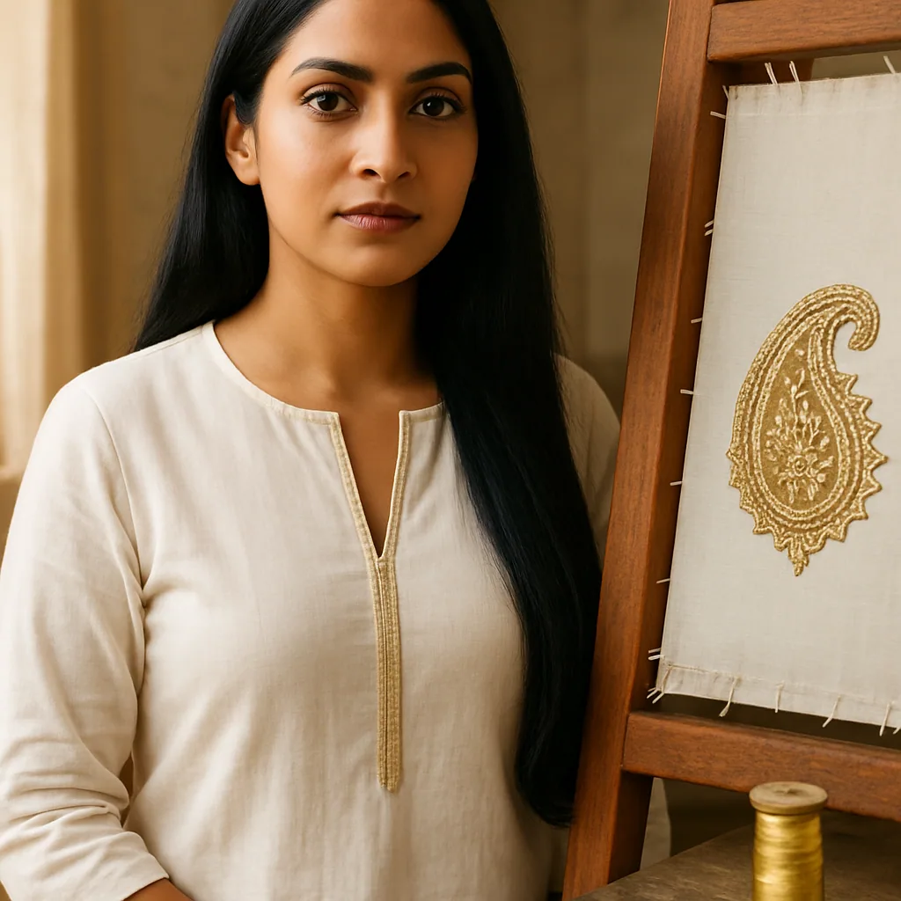
team-riya.webp
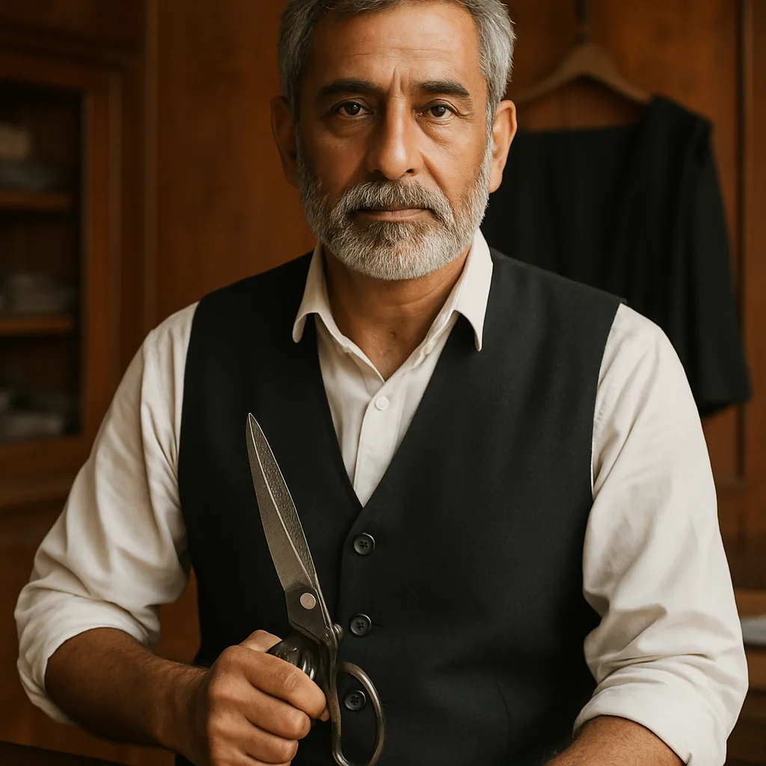
team-vikram.webp

Master shotlist
A single tickable list. Print this section, mark off each row as it is delivered.
File | Kind | Angle / Label | Spec & folder
acetate-glasses/01-front.webp | Tailored | Front | 3:4 · 1200×1600 · /public/generated/acetate-glasses/
acetate-glasses/02-overview.webp | Tailored | Overview | 3:4 · 1200×1600 · /public/generated/acetate-glasses/
acetate-glasses/03-side.webp | Tailored | Side | 3:4 · 1200×1600 · /public/generated/acetate-glasses/
acetate-glasses/04-back.webp | Tailored | Back | 3:4 · 1200×1600 · /public/generated/acetate-glasses/
acetate-glasses/05-detail.webp | Tailored | Detail | 3:4 · 1200×1600 · /public/generated/acetate-glasses/
aria-pant-suit/01-front.webp | Tailored | Front | 3:4 · 1200×1600 · /public/generated/aria-pant-suit/
aria-pant-suit/02-overview.webp | Tailored | Overview | 3:4 · 1200×1600 · /public/generated/aria-pant-suit/
aria-pant-suit/03-side.webp | Tailored | Side | 3:4 · 1200×1600 · /public/generated/aria-pant-suit/
aria-pant-suit/04-back.webp | Tailored | Back | 3:4 · 1200×1600 · /public/generated/aria-pant-suit/
aria-pant-suit/05-detail.webp | Tailored | Detail | 3:4 · 1200×1600 · /public/generated/aria-pant-suit/
black-tie-tuxedo/01-front.webp | Tailored | Front | 3:4 · 1200×1600 · /public/generated/black-tie-tuxedo/
black-tie-tuxedo/02-overview.webp | Tailored | Overview | 3:4 · 1200×1600 · /public/generated/black-tie-tuxedo/
black-tie-tuxedo/03-side.webp | Tailored | Side | 3:4 · 1200×1600 · /public/generated/black-tie-tuxedo/
black-tie-tuxedo/04-back.webp | Tailored | Back | 3:4 · 1200×1600 · /public/generated/black-tie-tuxedo/
black-tie-tuxedo/05-detail.webp | Tailored | Detail | 3:4 · 1200×1600 · /public/generated/black-tie-tuxedo/
calfskin-belt/01-front.webp | Tailored | Front | 3:4 · 1200×1600 · /public/generated/calfskin-belt/
calfskin-belt/02-overview.webp | Tailored | Overview | 3:4 · 1200×1600 · /public/generated/calfskin-belt/
calfskin-belt/03-side.webp | Tailored | Side | 3:4 · 1200×1600 · /public/generated/calfskin-belt/
calfskin-belt/04-back.webp | Tailored | Back | 3:4 · 1200×1600 · /public/generated/calfskin-belt/
calfskin-belt/05-detail.webp | Tailored | Detail | 3:4 · 1200×1600 · /public/generated/calfskin-belt/
camel-trench/01-front.webp | Tailored | Front | 3:4 · 1200×1600 · /public/generated/camel-trench/
camel-trench/02-overview.webp | Tailored | Overview | 3:4 · 1200×1600 · /public/generated/camel-trench/
camel-trench/03-side.webp | Tailored | Side | 3:4 · 1200×1600 · /public/generated/camel-trench/
camel-trench/04-back.webp | Tailored | Back | 3:4 · 1200×1600 · /public/generated/camel-trench/
camel-trench/05-detail.webp | Tailored | Detail | 3:4 · 1200×1600 · /public/generated/camel-trench/
embroidered-lehenga/01-front.webp | Tailored | Front | 3:4 · 1200×1600 · /public/generated/embroidered-lehenga/
embroidered-lehenga/02-overview.webp | Tailored | Overview | 3:4 · 1200×1600 · /public/generated/embroidered-lehenga/
embroidered-lehenga/03-side.webp | Tailored | Side | 3:4 · 1200×1600 · /public/generated/embroidered-lehenga/
embroidered-lehenga/04-back.webp | Tailored | Back | 3:4 · 1200×1600 · /public/generated/embroidered-lehenga/
embroidered-lehenga/05-detail.webp | Tailored | Detail | 3:4 · 1200×1600 · /public/generated/embroidered-lehenga/
festive-sherwani/01-front.webp | Tailored | Front | 3:4 · 1200×1600 · /public/generated/festive-sherwani/
festive-sherwani/02-overview.webp | Tailored | Overview | 3:4 · 1200×1600 · /public/generated/festive-sherwani/
festive-sherwani/03-side.webp | Tailored | Side | 3:4 · 1200×1600 · /public/generated/festive-sherwani/
festive-sherwani/04-back.webp | Tailored | Back | 3:4 · 1200×1600 · /public/generated/festive-sherwani/
festive-sherwani/05-detail.webp | Tailored | Detail | 3:4 · 1200×1600 · /public/generated/festive-sherwani/
grandad-collar-shirt/01-front.webp | Tailored | Front | 3:4 · 1200×1600 · /public/generated/grandad-collar-shirt/
grandad-collar-shirt/02-overview.webp | Tailored | Overview | 3:4 · 1200×1600 · /public/generated/grandad-collar-shirt/
grandad-collar-shirt/03-side.webp | Tailored | Side | 3:4 · 1200×1600 · /public/generated/grandad-collar-shirt/
grandad-collar-shirt/04-back.webp | Tailored | Back | 3:4 · 1200×1600 · /public/generated/grandad-collar-shirt/
grandad-collar-shirt/05-detail.webp | Tailored | Detail | 3:4 · 1200×1600 · /public/generated/grandad-collar-shirt/
hand-laced-corset/01-front.webp | Tailored | Front | 3:4 · 1200×1600 · /public/generated/hand-laced-corset/
hand-laced-corset/02-overview.webp | Tailored | Overview | 3:4 · 1200×1600 · /public/generated/hand-laced-corset/
hand-laced-corset/03-side.webp | Tailored | Side | 3:4 · 1200×1600 · /public/generated/hand-laced-corset/
hand-laced-corset/04-back.webp | Tailored | Back | 3:4 · 1200×1600 · /public/generated/hand-laced-corset/
hand-laced-corset/05-detail.webp | Tailored | Detail | 3:4 · 1200×1600 · /public/generated/hand-laced-corset/
heritage-three-piece/01-front.webp | Tailored | Front | 3:4 · 1200×1600 · /public/generated/heritage-three-piece/
heritage-three-piece/02-overview.webp | Tailored | Overview | 3:4 · 1200×1600 · /public/generated/heritage-three-piece/
heritage-three-piece/03-side.webp | Tailored | Side | 3:4 · 1200×1600 · /public/generated/heritage-three-piece/
heritage-three-piece/04-back.webp | Tailored | Back | 3:4 · 1200×1600 · /public/generated/heritage-three-piece/
heritage-three-piece/05-detail.webp | Tailored | Detail | 3:4 · 1200×1600 · /public/generated/heritage-three-piece/
italian-pleated-trouser/01-front.webp | Tailored | Front | 3:4 · 1200×1600 · /public/generated/italian-pleated-trouser/
italian-pleated-trouser/02-overview.webp | Tailored | Overview | 3:4 · 1200×1600 · /public/generated/italian-pleated-trouser/
italian-pleated-trouser/03-side.webp | Tailored | Side | 3:4 · 1200×1600 · /public/generated/italian-pleated-trouser/
italian-pleated-trouser/04-back.webp | Tailored | Back | 3:4 · 1200×1600 · /public/generated/italian-pleated-trouser/
italian-pleated-trouser/05-detail.webp | Tailored | Detail | 3:4 · 1200×1600 · /public/generated/italian-pleated-trouser/
lapel-brooch-set/01-front.webp | Tailored | Front | 3:4 · 1200×1600 · /public/generated/lapel-brooch-set/
lapel-brooch-set/02-overview.webp | Tailored | Overview | 3:4 · 1200×1600 · /public/generated/lapel-brooch-set/
lapel-brooch-set/03-side.webp | Tailored | Side | 3:4 · 1200×1600 · /public/generated/lapel-brooch-set/
lapel-brooch-set/04-back.webp | Tailored | Back | 3:4 · 1200×1600 · /public/generated/lapel-brooch-set/
lapel-brooch-set/05-detail.webp | Tailored | Detail | 3:4 · 1200×1600 · /public/generated/lapel-brooch-set/
linen-bandhgala/01-front.webp | Tailored | Front | 3:4 · 1200×1600 · /public/generated/linen-bandhgala/
linen-bandhgala/02-overview.webp | Tailored | Overview | 3:4 · 1200×1600 · /public/generated/linen-bandhgala/
linen-bandhgala/03-side.webp | Tailored | Side | 3:4 · 1200×1600 · /public/generated/linen-bandhgala/
linen-bandhgala/04-back.webp | Tailored | Back | 3:4 · 1200×1600 · /public/generated/linen-bandhgala/
linen-bandhgala/05-detail.webp | Tailored | Detail | 3:4 · 1200×1600 · /public/generated/linen-bandhgala/
midnight-slip-dress/01-front.webp | Tailored | Front | 3:4 · 1200×1600 · /public/generated/midnight-slip-dress/
midnight-slip-dress/02-overview.webp | Tailored | Overview | 3:4 · 1200×1600 · /public/generated/midnight-slip-dress/
midnight-slip-dress/03-side.webp | Tailored | Side | 3:4 · 1200×1600 · /public/generated/midnight-slip-dress/
midnight-slip-dress/04-back.webp | Tailored | Back | 3:4 · 1200×1600 · /public/generated/midnight-slip-dress/
midnight-slip-dress/05-detail.webp | Tailored | Detail | 3:4 · 1200×1600 · /public/generated/midnight-slip-dress/
raw-silk-saree/01-front.webp | Tailored | Front | 3:4 · 1200×1600 · /public/generated/raw-silk-saree/
raw-silk-saree/02-overview.webp | Tailored | Overview | 3:4 · 1200×1600 · /public/generated/raw-silk-saree/
raw-silk-saree/03-side.webp | Tailored | Side | 3:4 · 1200×1600 · /public/generated/raw-silk-saree/
raw-silk-saree/04-back.webp | Tailored | Back | 3:4 · 1200×1600 · /public/generated/raw-silk-saree/
raw-silk-saree/05-detail.webp | Tailored | Detail | 3:4 · 1200×1600 · /public/generated/raw-silk-saree/
tailored-pencil-skirt/01-front.webp | Tailored | Front | 3:4 · 1200×1600 · /public/generated/tailored-pencil-skirt/
tailored-pencil-skirt/02-overview.webp | Tailored | Overview | 3:4 · 1200×1600 · /public/generated/tailored-pencil-skirt/
tailored-pencil-skirt/03-side.webp | Tailored | Side | 3:4 · 1200×1600 · /public/generated/tailored-pencil-skirt/
tailored-pencil-skirt/04-back.webp | Tailored | Back | 3:4 · 1200×1600 · /public/generated/tailored-pencil-skirt/
tailored-pencil-skirt/05-detail.webp | Tailored | Detail | 3:4 · 1200×1600 · /public/generated/tailored-pencil-skirt/
tapered-wool-trouser/01-front.webp | Tailored | Front | 3:4 · 1200×1600 · /public/generated/tapered-wool-trouser/
tapered-wool-trouser/02-overview.webp | Tailored | Overview | 3:4 · 1200×1600 · /public/generated/tapered-wool-trouser/
tapered-wool-trouser/03-side.webp | Tailored | Side | 3:4 · 1200×1600 · /public/generated/tapered-wool-trouser/
tapered-wool-trouser/04-back.webp | Tailored | Back | 3:4 · 1200×1600 · /public/generated/tapered-wool-trouser/
tapered-wool-trouser/05-detail.webp | Tailored | Detail | 3:4 · 1200×1600 · /public/generated/tapered-wool-trouser/
two-piece-italian/01-front.webp | Tailored | Front | 3:4 · 1200×1600 · /public/generated/two-piece-italian/
two-piece-italian/02-overview.webp | Tailored | Overview | 3:4 · 1200×1600 · /public/generated/two-piece-italian/
two-piece-italian/03-side.webp | Tailored | Side | 3:4 · 1200×1600 · /public/generated/two-piece-italian/
two-piece-italian/04-back.webp | Tailored | Back | 3:4 · 1200×1600 · /public/generated/two-piece-italian/
two-piece-italian/05-detail.webp | Tailored | Detail | 3:4 · 1200×1600 · /public/generated/two-piece-italian/
velvet-blazer-dress/01-front.webp | Tailored | Front | 3:4 · 1200×1600 · /public/generated/velvet-blazer-dress/
velvet-blazer-dress/02-overview.webp | Tailored | Overview | 3:4 · 1200×1600 · /public/generated/velvet-blazer-dress/
velvet-blazer-dress/03-side.webp | Tailored | Side | 3:4 · 1200×1600 · /public/generated/velvet-blazer-dress/
velvet-blazer-dress/04-back.webp | Tailored | Back | 3:4 · 1200×1600 · /public/generated/velvet-blazer-dress/
velvet-blazer-dress/05-detail.webp | Tailored | Detail | 3:4 · 1200×1600 · /public/generated/velvet-blazer-dress/
wide-calfskin-belt/01-front.webp | Tailored | Front | 3:4 · 1200×1600 · /public/generated/wide-calfskin-belt/
wide-calfskin-belt/02-overview.webp | Tailored | Overview | 3:4 · 1200×1600 · /public/generated/wide-calfskin-belt/
wide-calfskin-belt/03-side.webp | Tailored | Side | 3:4 · 1200×1600 · /public/generated/wide-calfskin-belt/
wide-calfskin-belt/04-back.webp | Tailored | Back | 3:4 · 1200×1600 · /public/generated/wide-calfskin-belt/
wide-calfskin-belt/05-detail.webp | Tailored | Detail | 3:4 · 1200×1600 · /public/generated/wide-calfskin-belt/
fabric-egyptian-poplin/ivory/front.webp | Fabric (primary) | Front | 2:3 · 1440×2160 · /public/generated/fabric-egyptian-poplin/ivory/
fabric-egyptian-poplin/ivory/drape.webp | Fabric (primary) | Drape | 2:3 · 1440×2160 · /public/generated/fabric-egyptian-poplin/ivory/
fabric-egyptian-poplin/ivory/lay.webp | Fabric (primary) | Lay | 2:3 · 1440×2160 · /public/generated/fabric-egyptian-poplin/ivory/
fabric-egyptian-poplin/ivory/detail.webp | Fabric (primary) | Detail | 2:3 · 1440×2160 · /public/generated/fabric-egyptian-poplin/ivory/
fabric-heavy-linen/sand/front.webp | Fabric (primary) | Front | 2:3 · 1440×2160 · /public/generated/fabric-heavy-linen/sand/
fabric-heavy-linen/sand/drape.webp | Fabric (primary) | Drape | 2:3 · 1440×2160 · /public/generated/fabric-heavy-linen/sand/
fabric-heavy-linen/sand/lay.webp | Fabric (primary) | Lay | 2:3 · 1440×2160 · /public/generated/fabric-heavy-linen/sand/
fabric-heavy-linen/sand/detail.webp | Fabric (primary) | Detail | 2:3 · 1440×2160 · /public/generated/fabric-heavy-linen/sand/
fabric-heavy-linen/slate/front.webp | Fabric (secondary) | Front | 2:3 · 1440×2160 · /public/generated/fabric-heavy-linen/slate/
fabric-italian-wool-super-120s/charcoal/front.webp | Fabric (primary) | Front | 2:3 · 1440×2160 · /public/generated/fabric-italian-wool-super-120s/charcoal/
fabric-italian-wool-super-120s/charcoal/drape.webp | Fabric (primary) | Drape | 2:3 · 1440×2160 · /public/generated/fabric-italian-wool-super-120s/charcoal/
fabric-italian-wool-super-120s/charcoal/lay.webp | Fabric (primary) | Lay | 2:3 · 1440×2160 · /public/generated/fabric-italian-wool-super-120s/charcoal/
fabric-italian-wool-super-120s/charcoal/detail.webp | Fabric (primary) | Detail | 2:3 · 1440×2160 · /public/generated/fabric-italian-wool-super-120s/charcoal/
fabric-italian-wool-super-120s/bone/front.webp | Fabric (secondary) | Front | 2:3 · 1440×2160 · /public/generated/fabric-italian-wool-super-120s/bone/
fabric-italian-wool-super-120s/navy/front.webp | Fabric (secondary) | Front | 2:3 · 1440×2160 · /public/generated/fabric-italian-wool-super-120s/navy/
fabric-italian-wool-super-120s/stone/front.webp | Fabric (secondary) | Front | 2:3 · 1440×2160 · /public/generated/fabric-italian-wool-super-120s/stone/
fabric-raw-silk-handwoven/wine/front.webp | Fabric (primary) | Front | 2:3 · 1440×2160 · /public/generated/fabric-raw-silk-handwoven/wine/
fabric-raw-silk-handwoven/wine/drape.webp | Fabric (primary) | Drape | 2:3 · 1440×2160 · /public/generated/fabric-raw-silk-handwoven/wine/
fabric-raw-silk-handwoven/wine/lay.webp | Fabric (primary) | Lay | 2:3 · 1440×2160 · /public/generated/fabric-raw-silk-handwoven/wine/
fabric-raw-silk-handwoven/wine/detail.webp | Fabric (primary) | Detail | 2:3 · 1440×2160 · /public/generated/fabric-raw-silk-handwoven/wine/
fabric-raw-silk-handwoven/emerald/front.webp | Fabric (secondary) | Front | 2:3 · 1440×2160 · /public/generated/fabric-raw-silk-handwoven/emerald/
fabric-raw-silk-handwoven/ivory/front.webp | Fabric (secondary) | Front | 2:3 · 1440×2160 · /public/generated/fabric-raw-silk-handwoven/ivory/
_hero/premium.webp | Hero | Tile | 3:4 · 1100×1466 · /public/generated/_hero/
_hero/new-arrivals.webp | Hero | Tile | 3:4 · 1100×1466 · /public/generated/_hero/
_hero/made-to-measure.webp | Hero | Tile | 3:4 · 1100×1466 · /public/generated/_hero/
_sections/atelier.webp | Editorial | Split / teaser | Square-safe · 1400×1400 · /public/generated/_sections/
_sections/womens-edit.webp | Editorial | Split | Square-safe · 1400×1400 · /public/generated/_sections/
_sections/service-bespoke.webp | Service | Card | 4:3 · 1200×900 · /public/generated/_sections/
_sections/service-sherwani.webp | Service | Card | 4:3 · 1200×900 · /public/generated/_sections/
_sections/service-shirts.webp | Service | Card | 4:3 · 1200×900 · /public/generated/_sections/
_sections/process-cloth.webp | Process | Step 1 | 4:3 · 1200×900 · /public/generated/_sections/
_sections/process-measure.webp | Process | Step 2 | 4:3 · 1200×900 · /public/generated/_sections/
_sections/process-finish.webp | Process | Step 3 | 4:3 · 1200×900 · /public/generated/_sections/
_sections/editorial-wedding.webp | Editorial | Wedding | 4:5 · 1400×1200 · /public/generated/_sections/
_sections/swim-banner.webp | Banner | Landscape | 3:1 · 2400×800 · /public/generated/_sections/
_team/team-aman.webp | Portrait | Designer | 1:1 · 800×800 · /public/generated/_team/
_team/team-riya.webp | Portrait | Designer | 1:1 · 800×800 · /public/generated/_team/
_team/team-vikram.webp | Portrait | Designer | 1:1 · 800×800 · /public/generated/_team/

Delivery & handoff
Archive | Single .zip named elitezonej-shoot-{YYYY-MM-DD}.zip
Folder layout | /assets/ (final .webp)  /masters/ (.tiff or 16-bit .png)  /contact-sheet.pdf  /shotlist.csv (slug, file, status, retouched-by, date)
Naming | Identical to the file paths in this brief. Lowercase, kebab-case, .webp.
Resolution | Delivered at 2× the listed minimum (Retina). Crops applied non-destructively from the master.
Colour | Embed sRGB profile in every .webp. Master files retain working space.
Deadline | [ photographer to confirm ]
Contact | [ project lead to fill in ]

Sign-off — by delivering against this brief the photographer confirms each image meets the listed specification and is licensed for unrestricted use on the Elite Zone J website, store, marketing, and print collateral.

